Module Six
I Am Still Me!
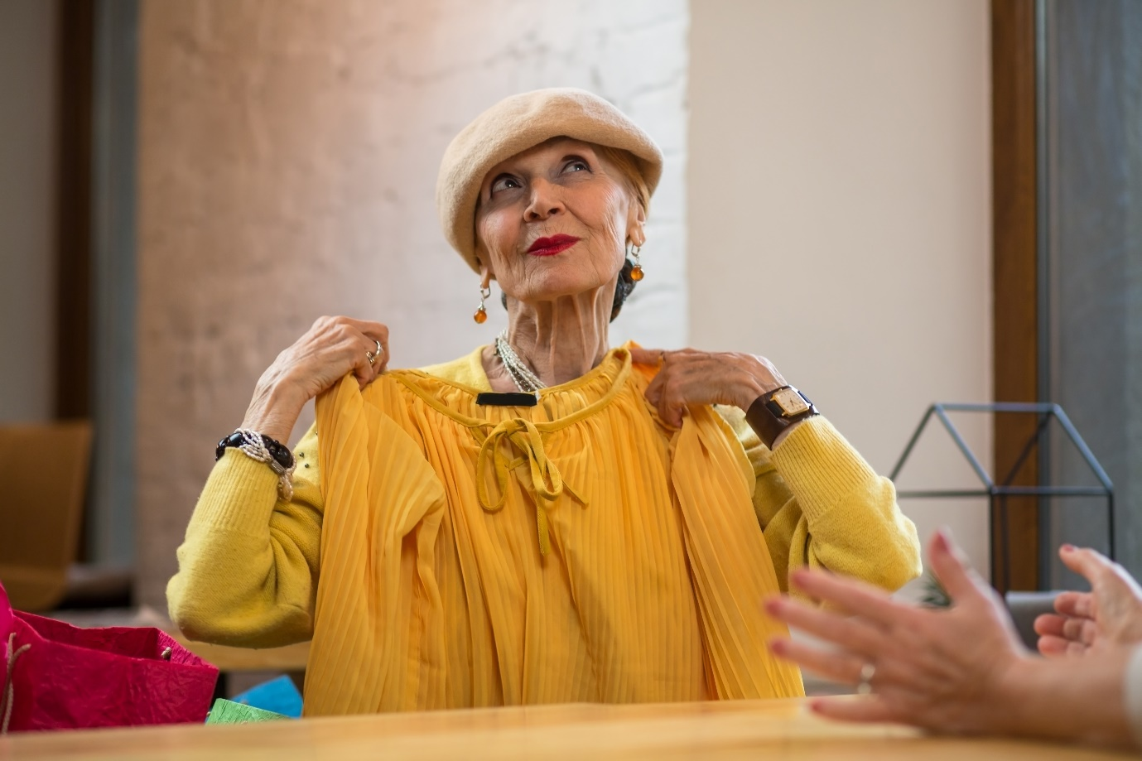

ACTIVITY BOOK

Name:
Date completed:

Manager’s signature on completion:

Well done!! Awesome, you are nearly there! what a fabulous achievement. I hope that this in itself will help raise your self-esteem and help you realise your worth in sticking at the training, reflecting on how it has impacted your practice. – Over time, I am sure you will gain more and more confidence in your role when caring with a person living with dementia.
Just to recap over the past modules, you have learnt what dementia is, how it can affect people in different ways, how to help them with communicating and connecting by understanding how memory works and how to use their life stories and reminiscence. You have explored aspects of how environments can help or hinder a person and how moods, emotions and responses can be triggered. By understanding this you will find your role increasingly satisfying when you know how to help and support the people you care with and it will help in supporting you too.
One thing to say, is that you will never stop learning, I am constantly finding out more about dementia from the people who are living day to day with the different conditions and the latest research. I hope this training will have opened your mind to caring for yourself too and recommend that you regularly go back over your Activity Books and Reflective Journals to jog your memories and inspire you to keep learning. Reflection is an ongoing process, and I recommend that you continue to do this with your buddy, colleagues and manager.
Jane
Dr. Jane M. Mullins Dementia Nurse Specialist
Founder of Finding the Light in Dementia®

Module Six
I Am Still Me!
It is an absolute human certainty that no one can know his own beauty or perceive a sense of his own worth until it has been reflected back to him in the mirror of another loving, caring human being
Joseph John Powell

In this Module, we are going to build on all that we have learnt from the previous modules, to make sure that we do actually deliver person centred care. We will find out more about how to deliver personal care in an informed way, and help maintain the person’s sense of self with dignity. We will do this by watching films, animations and presentations, and listening to audios. These resources involve people who have dementia, family members, carers and professionals and researchers working within the field.
This training will have given you more confidence and spark off your own ideas to help people living with dementia and their loved ones. Your manager should be there to support you and don’t forget to work closely with your buddy and other colleagues. A number of these activities may bring out a number of emotions, so don’t forget to speak with your manager (or trusted friend/colleague) about this and visit our Wellbeing Hub.

This Activity Book has a mixture of notes pages for you to write in when watching the presentations and other resources in each lesson and activities to complete.

Don’t forget the Wellbeing Hub will help you with many of your self-care needs during this training. However, it is not a substitute for medical advice and DUETcare Ltd cannot be held responsible for your health and wellbeing. If at any time you feel overwhelmed and needing support, please speak with your manager/buddy or trusted friend and seek medical help where required.
Activities

One: A Day in the Life of 5

Two: Tree of Life 10

Three: Three Things Learnt 12

Four: Reflection on Rachel’s Story in Module One 13

Five: Reflection on This is Me! 14

Six: Key Takeaways 16

Activity One: A Day in the Life of……………….

I’d like you to choose a person that you care with and imagine how their day is (you could do this over a period of days). Fill out how they experience their day, try and find out from them. Then complete the diary below: As you do this, check that their wishes are being respected. For example, what time of day they like to get up.

7am

8am

9am

10am

11am

12 Midday

1pm

2pm

3pm

4pm

5pm

Activity One: A Day in the Life of cont……………….

6pm

7pm

8pm

9pm

10

11pm

12 Midnight

1am

2am

3am

4am

5am

6am

Activity One: A Day in the Life of cont……………….
How do you think……. …… . feels about his/her day? Do they have a balance between activities and rest? Think of all that you have learnt, are they involved in some form of communication with others?

Now write down how you would feel if this was you?

Activity One: A Day in the Life of cont……………….

Think about communication, memories and environment and is there anything you could do to enhance their day? If so, what can you do? Write in the box below (there may be a number of things). Once you have identified any changes you’d like to make, speak with your manager, colleagues, the person and their family. This information can then be transferred to their care plan.

Activity One: A Day in the Life of cont……………….

What changes have you made and have you noticed any responses at all in the person? Make sure you put in the date and times of any changes.

Activity Two: Tree of Life

This activity is a metaphor where a tree depicts parts of your life—past, present, and future.

Firstly, you can draw your own tree, note that it has leaves, branches, a trunk and roots. You can even include a compost heap.

Each part of the tree represents something about you. Within each part of the tree, I would like you to draw or write something about you. See on the next page for a guide.

Activity Two: Tree of Life cont.….

Compost Heap: Write in here anything that may have been negative in your life, any difficulties with your confidence and self esteem (hopefully our previous activities will be helping you with this too). These negative thoughts could involve other people, experiences, places. Think, that these are the things that you do not want to define you anymore.

Roots: Write in here about things, experiences, places and people in your past who have had a positive impact on you when growing up.

Ground: Write in here about people, places, activities, and other things that you choose to do regularly because they nurture you and bring you joy.

Trunk: Write in here about the skills and values that define who you are at the present moment. It would be good to choose what are most important to you, the ones at which you do well and that others often see in you.

Branches: Write in here about your wishes, hopes, dreams. They may be personal, family, or include friends and in your community. These can be short and long term, whatever are most important to you as you plan your future.

Leaves: Write in here about the people who are important to you now, and most likely will remain important as you follow your wishes, hopes and dreams.

Activity Three: Three Things Learnt
Write down 3 things you have learnt since you started Module Six.

Activity Four: Reflection on Rachel’s Story in Module One

Go back to your Module One Activity Book and read through your responses. Now that you have undertaken the rest of the Modules, see if you can think of any other ways, you might be able to help Rachel. Write in with a different colour pen from your first attempt. Write below any changes you have noted and what you have learnt.

Activity Five: Reflection on This is Me
Go back to your Module One Activity Book and see is there anything you would like to add in the This is Me activity since completing these modules. You can write below or in Module One’s Activity Book in a different colour. This may show how what you have learnt may impact on what matters most to you too.

Here are Some Key Takeaways from Finding the Light in Dementia® Training

- Feelings often dominate thinking, people who have dementia often communicate through their emotions

- Tap in to your intuition

- Find meaningful and creative ways to communicate through the senses

- It is ok to sit in silence and just BE with a person

- People respond in ways due to fear and insecurity – challenge terms such as “challenging behaviour

- Don’t underestimate the importance of a person’s life history (including. possible traumatic events that may shape their emotions & subsequent responses to triggers in the present)

- Find the real essence of the person beyond cognition (the thinking self), the sense of self (the feeling self), focus on their strengths

- Look and listen to the surroundings and environment, is it creating shadows & confusion? - how can minor changes help? reduce noise levels, increase light

- Communicate with families and friends (the people who know them well)

- Consider using a pain assessment tool especially where people struggle to communicate.

Activity Six: Key Takeaways

Write below the key things that you have learnt during your training below. You can keep adding to this list. This can include things about yourself too.

Activity Six: Key Takeaways cont.….

Write in the box below things that you have done to implement positive approaches in how you practise and how that has impacted on people you care with and your colleagues.

Activity Six: Key Takeaways cont.….

Write in the box below things that you have done to implement positive approaches in how you practise and how that has impacted on people you care with and your colleagues.

Well done, you did it!!!

For completing Finding the Light in Dementia®Training

You should now understand what dementia is and how the different conditions affect people in different ways, know how to help communicate, and use life stories and reminiscence to help connect with them. You will know how the surroundings and environment can affect a person’s moods, emotions and responses and how to help them maintain a sense of themselves with dignity and empathy. You should also be feeling more confident in your role and learnt ways of being kind to yourself.

Don’t forget to answer the questions at the end of the module to release your Certificate and store safely in your file with all of your Activity Books and Reflective Journals.

Jane
Dr. Jane M. Mullins Dementia Nurse Specialist
Founder of Finding the Light in Dementia®

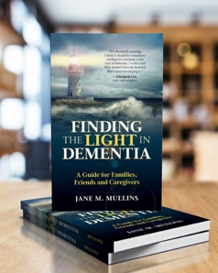

http://amzn.to/2ARCwDI

All rights reserved. This activity book is only to be downloaded and completed by each individual trainee. No part of this training may be copied for use other than intended for each trainee. This training programme is the culmination of over 30 years’ practice and experience in dementia care and teaching in Health and Social Care and contributions by people living with dementia and professionals working within the field. Please see terms and conditions at www.findingthelightindementiacaretraining.com for full details.

