Module Five
Understanding Moods, Emotions
and Responses
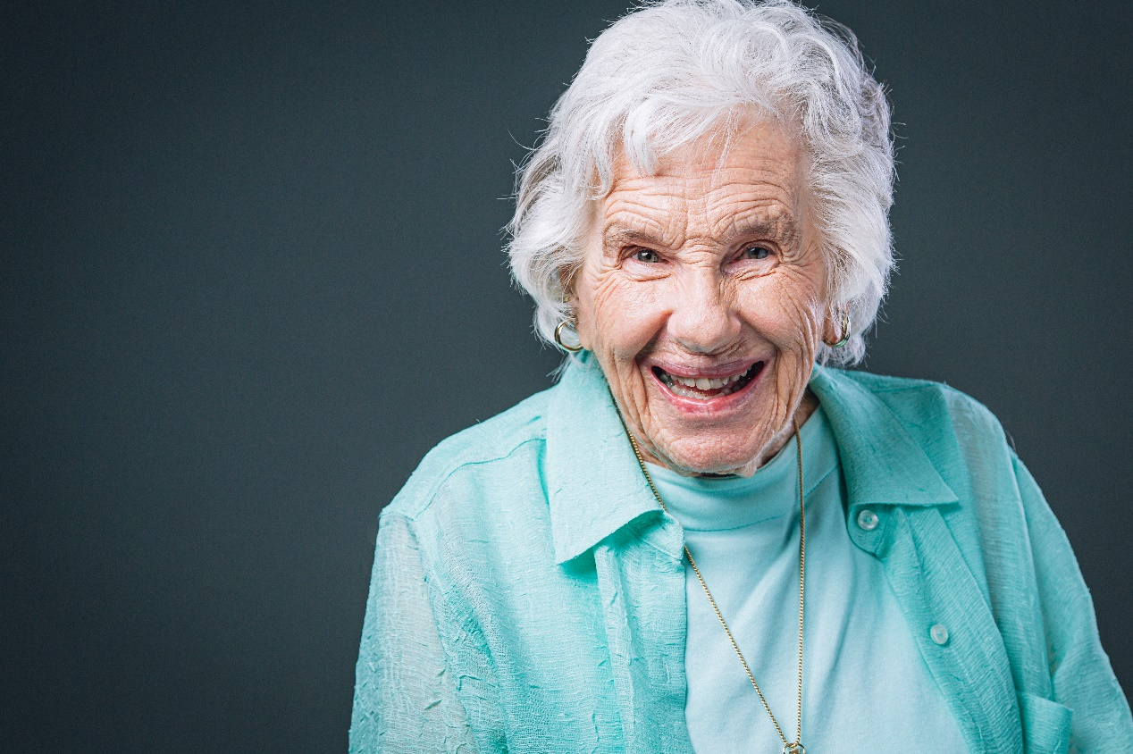
REFLECTIVE JOURNAL

Name:
Date Completed:

Manager’s signature on completion:

Why do we need to reflect?

Personal

- Helps us understand about how we respond & react to situations
- Helps us to identify personal targets & goals
- Increases a sense of wider issues
- Increases a sense of social justice
- Helps to facilitate change
- A form of learning & development

Professional
- Learning through practice
- Enhances practice
- Initiates change for good
- Maintains motivation
- Helps to motivate others
- Share knowledge
- Develop critical thinking
- Linked to professional standards

Don’t forget to work with your manager and buddy, you can all help each other to talk through situations that you are reflecting on. It would be a great idea to go back over your reflections when you complete Module Six to help you see if you would do things differently since undertaking the training. Keep this Reflective Journal together with your Journals from the previous modules.

Be kind to yourself, and once you have written your reflections, go to the wellbeing hub to enjoy some self-care.

Title of Reflection 1:

Description - What Happened?

Feelings - What I was thinking and feeling?

Evaluation - What was good and bad?

Title of Reflection 1 cont.:

Analysis - What sense did I make of the situation?

Analysis - What else could I have done?

Action Plan - If it arose again, what would I do?

Notes Pages
These are additional pages for you to jot down any thoughts, feelings and actions you feel would help you in your care practice following your reflections.

Title of Reflection 2:

Description - What Happened?

Feelings - What I was thinking and feeling?

Evaluation - What was good and bad?

Title of Reflection 2 cont.:

Analysis - What sense did I make of the situation?

Analysis - What else could I have done?

Action Plan - If it arose again, what would I do?
Notes Pages
These are additional pages for you to jot down any thoughts, feelings and actions you feel would help you in your care practice following your reflections.

Title of Reflection 3:

Description - What Happened?

Feelings - What I was thinking and feeling?

Evaluation - What was good and bad?

Title of Reflection 3 cont.:

Analysis - What sense did I make of the situation?

Analysis - What else could I have done?

Action Plan - If it arose again, what would I do?

Notes Pages
These are additional pages for you to jot down any thoughts, feelings and actions you feel would help you in your care practice following your reflections.

Well done, you have really made a start on reflecting on your practice and on how the training is starting to help you understand more about dementia and how it can help yourself to help the people you are caring for. We will continue with more of our reflections in the next modules.

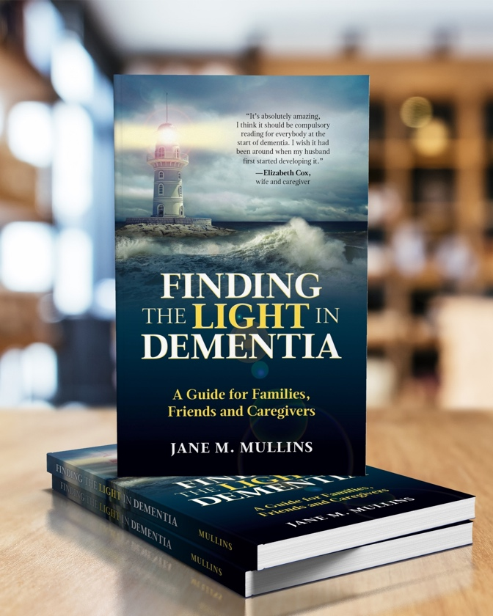

All rights reserved. This journal is only to be downloaded and completed by each individual trainee. No part of this training may be copied for use other than that intended for each trainee. This training programme is the culmination of over 30 years’ practice and experience in dementia care and teaching in Health and Social Care and contributions by people living with dementia and professionals working within the field. Please see terms and conditions on the www.findingthelightindementiacaretraining.com for full details.

