Module Four
Creating a Calm Safe Place

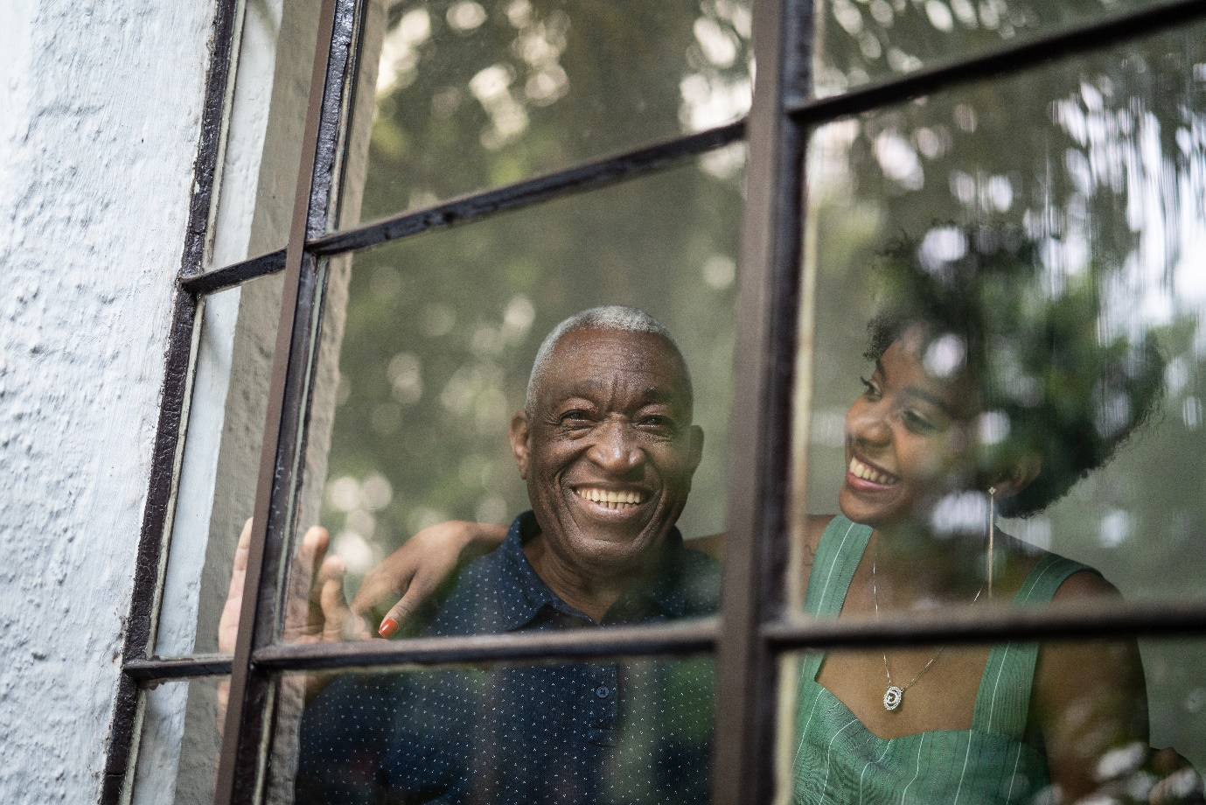
ACTIVITY BOOK

Name:
Date completed:

Manager’s signature on completion:

Congratulations!! you are over halfway! How do you feel? Don’t forget to write it down in your Reflective Journal, have there been times when you have found it tough? If everything was easy in life, nobody would achieve anything – imagine how great you are going to feel as you complete this next module. Just to recap over the past three modules, you have learnt what dementia is, how it can affect people in different ways, how you can help the person with communicating and connecting, by understanding how memory works and how to use their life stories and reminiscence. Now we are going to explore how surroundings can affect a person living with dementia. This can be indoor and outdoor areas and we will learn how we can create calm safe places that will help the person feel a sense of safety and wellbeing.
As you go through the resources you will find novel ways of helping people who have dementia enjoy their surroundings, coupled with all that you have learned in the previous modules, you will find your role increasingly satisfying when you know how to help and support the people you care with. Also don’t forget to use your Reflective Journal to reflect on your thoughts, ideas and insights. Remember a big part of this training is for your own development and involves some really enjoyable activities. Be kind to yourself by having breaks, go to the Wellbeing Hub and if you can go and get some fresh air in and around nature you will feel great. Jane
Jane M. Mullins Dementia Nurse Specialist
Founder of Finding the Light in Dementia®
Module Four
Creating a Calm Safe Place: Learning Outcomes
Home is where you feel at home and are treated well

Dalai Lama

In this Module, we are going to build on our knowledge about how dementia can affect a person’s hearing and vision and how this can impact on how they experience their surroundings. We will learn about how our internal and external environments can affect our moods and how they can affect a person living with dementia. We will also be exploring aspects of sleep and falls. We will learn about how dementia can affect the way a person sees their world around them and how we can create calm safe places for them to feel well. We will do this by watching films, animations and presentations, and listening to audios. These resources will involve people who have dementia, family members, carers and professionals and researchers working within the field.
Using strength-based approaches we will go on to examine how enhancing a person’s surroundings can help them retain their existing skills for as long as possible and to help support us in providing person centred care.
This training will give you more confidence and spark off your own ideas to help people living with dementia and their loved ones. Your manager will be there to support you and don’t forget to work closely with your buddy and other colleagues. A number of these activities may bring out a number of emotions, so don’t forget to speak with your manager (or trusted friend/colleague) about this and visit our Wellbeing Hub.

This Activity Book has a mixture of notes pages for you to write in when watching the presentations and other resources in each lesson and activities to complete.

Don’t forget the Wellbeing Hub will help you with many of your self-care needs during this training. However, it is not a substitute for medical advice and DUETcare Ltd cannot be held responsible for your health and wellbeing. If at any time you feel overwhelmed and needing support, please speak with your manager/buddy or trusted friend and seek medical help where required.

Activities

One: What Home Means to Me 5

Two: Visual Impairment 8

Three: What is the Problem with this Place? 10

Four: Senses at Home 12

Five: Suzy’s Story 16

Six: Leaving Home 20

Seven: Three Things Learnt 23

Activity One: What HOME Means to Me

Often people who have dementia appear to be searching or wanting to “go home.” While we never quite know what or where they are looking for, we tend to think it may be a feeling of familiarity and safety. By you exploring what HOME means to you, you will realise how it means different things to different people.
This is a group activity and you will need at least 6 of you to do this. Gather together with your Activity Books, a large sheet of paper and pens and a favourite drink and snack. This works well if you have a facilitator, such as your manager to keep the activity going and to make a verbal contract to agree that all that is discussed in the group, stays in the group and that everyone’s voice is listened to and respected.
Where possible, sit in a circle and take it in turns to answer the question
What does HOME means to you?
e.g.,” HOME means being surrounded by my loved ones”
“HOME means feeling safe”
Let each person express their answer firstly, one at a time, so that everyone has a chance to speak. Write down on the paper everyone’s responses. You may want to put them into themes.
Once you have gone around the circle, explore your thoughts and feelings in more detail by discussing each answer/theme in more detail.
For instance, if someone says the word “security” – explore what this means for everyone, then write the responses on the paper. There are no right or wrong answers.
Be supportive of each other and try and have a bit of humour with this (but not at someone else’s expense). Once you have completed the activity (and you can do this more than once and with other people), write down all the words and themes that you agree with below. You may find that over time, these things may change.

Some of you may find that others will identify aspects of Home that you hadn’t thought about before, which is fine. The aim of this is to realise that we may all want different things, or we may find we have similar ideas. Be true to yourself and really think and feel for yourself.

Activity One: What HOME Means to Me cont...

Write down the words, themes, and images that help you feel “At Home” in the box below

Please be aware that sometimes these activities can bring up emotions inside us. If you find yourself feeling upset in any way, you can leave the room. Your manager will support you with this, and if you so feel upset, think a little of why that may be, and go to the Wellbeing Hub to help you find ways to support you too.

Activity One: What HOME Means to Me cont...

Write down the words, themes, and images that help you feel “At Home” in the box below

Activity Two: Visual Impairment
Close the curtains and darken the room, this is a group activity which can be conducted in any setting, you may be on your break or with your friends. At some point, whether sitting or standing, curl your thumb and first finger of both hands together to form a circle and put up to your eyes, as if you are looking through binoculars. Set a timer for four minutes, stay still for one minute, then walk around the room, keeping your fingers in place and stay looking ahead. Note the following:
What could you see and what couldn’t you see?

What were you thinking?

Activity Two: Visual Impairment cont…

How did you feel?

How did you respond, act, behave?

Activity Three: What is the Problem with this Place?

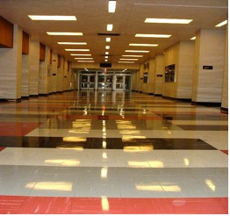
Think back to the previous slides on the presentation that show how people may be seeing and imagine how they may sense their world around them in this environment.

Activity Three: What is the problem with this place? cont…
Name the problems with this place and how the person may perceive them
e.g., It looks wet, it may appear slippery
e.g., The floor is shiny

Activity Four: Senses at Home
Often people who have dementia struggle to process all that surrounds them. If there is too much noise or the lights are too bright, they may feel overwhelmed. We need to understand how we can balance the person’s surroundings so that they are stimulated when they want to be and rested at other times. When sharing a place with others, people are put in a position of having to compromise their ways of living, our role is to help them feel calm, safe, comfortable and well. By exploring our needs, we can start to understand others.

This is a group activity and you will need at least 6 of you to do this. Gather together with your Activity Books, a large sheet of paper and pens and a favourite drink and snack. This works well if you have a facilitator, such as your manager to keep the activity going and to make a verbal contract to agree that all that is discussed in the group, stays in the group and that everyone’s voice is listened to and respected.

Divide the sheet of paper into 6 boxes (see the next page) that represent our senses – Seeing, Hearing, Feeling, Tasting, Smelling, Miscellaneous

Activity Four: Senses at Home cont….
Fill out the boxes with your responses from the questions on the next page:
Tasting
Multisensory
Smelling
Feeling
Hearing
Seeing

Activity Four: Senses at Home cont….
Ask yourselves the question:
- What irritates me when sharing my home space with others? (If you live alone, try to imagine what might irritate you).

Then put the answers into the boxes depending on your senses affected. If more than one sense is affected, write in the Multisensory Box.
e.g., I live with my teenage sons, their loud music and leaving every light on in the house irritates me at times!

(But I know that over time, that will change and I can take myself out of the situation.
People who have dementia may not be able to move so easily to a quieter place).

Take it in turns at first, give everyone their voice, then discuss each theme and note these down on a new sheet of paper.
Then go to

Question 2) What makes me feel calm, content and well at home?
Then put the answers into the boxes depending on the senses affected. If more than one sense is affected, write in the Multisensory Box. Again take it in turns at first, give everyone their voice, then discuss each theme and note these down on a new sheet of paper
e.g., I like gentle lighting and my own choice of music
Notice how different your responses are.
(Some people who have dementia may sit in a room and not appear to respond at all, which may give the impression that they are content in their environment. This may not be the case; they may have withdrawn and unable to express their displeasure and feel uncomfortable, whereas other people may show their displeasure by expressing frustration and agitation).
Activity Four: Senses at Home cont….
Fill out the boxes with your responses from the questions on the next page:
Tasting
Multisensory
Smelling
Feeling
Hearing
Seeing

Activity Five: Suzy’s Story

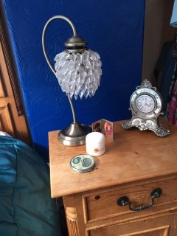
We’ll listen to Suzy’s story again from Module one
“One of the most important things we did when Mum moved in was to take her bedside cabinet with her and all that it contained. We made sure that her lamp and clock sat on the top in the same position as they had done for the past thirty years, stretching back to when she would get me up for school in the mornings!! She also had a favourite knitted toy that had always sat on top of the clock. I didn’t know what it was – from as far back as I can remember it had always been there, but I had never asked her about it. I later found out that she bought it as a souvenir when on honeymoon with my Dad. We never move it; we always keep it in the same position. We did this so even if Mum didn't know where she was or why she was there, she would feel some sense of familiarity when waking up and going to sleep”

What familiar things would help you feel more at home in another place? Write in the box below or take a photograph.

Activity Five: Suzy’s Story cont.…
Write, draw or put photographs in the box below of the familiar things that would help you feel more at home (I have added extra pages for you). Link back to Module One – My Favourite Things

Activity Five: Suzy’s Story cont.…
Write, draw or put photographs in the box below of the familiar things that would help you feel more at home (I have added extra pages for you) - Link back to Module One – My Favourite Things

Activity Five: Suzy’s Story cont.…
Write, draw or put photographs in the box below of the familiar things that would help you feel more at home (I have added extra pages for you) -Link back to Module One – My Favourite Things
Activity Six: Leaving Home

Have you ever had to move home? Can you remember back to that time? Many people moving into care, going into hospital or having their home modified may not have a choice, and they will feel many emotions. If you had to move home and leave your loved ones and familiar surroundings:

What would you be thinking?

What do you think your loved ones would be thinking?

How would you feel?

How would you loved ones feel?

Activity Six: Leaving Home cont…

How do you think you might respond/react?

How do you think your loved ones would respond/react?

What would be most upsetting?

What might frighten you?

Activity Six: Leaving Home cont…

What might comfort you?

Think about how you might help a person who is displaced from their home. How you might comfort them and write your thoughts here:

Activity Seven: Three Things Learnt
Write down 3 things you have learnt since you started Module Four.

Well done!!

For completing Module Four, “Creating a Calm Safe Place”

You should now be able to Understand about how dementia can affect a person’s vision and hearing and how this may impact on what they are sensing within their surroundings. You will also know more about sleep and how a lack can make a person more vulnerable to falls.
You will also be able to find enjoyable ways to create calmer, safer places for the people you care with.

If you are printing this up, I hope you have managed to get a file, as you can add the others from the next modules to it or you could create an electronic file for all of your Activity Books, Reflective Journals, Presentation Notes Pages and Certificates. By keeping it all together, you will see how your knowledge and skills will have developed and it will be a great resource to refer back to when you have completed the training.

Also don’t forget to use your Reflective Journal alongside to write down any extra notes, thoughts and observations. You can also learn more from my book, Finding the Light in Dementia: A Guide for Families, Friends and Caregivers.

Don’t forget to answer the questions at the end of the Module to release your certificate and store safely in your file and visit the Wellbeing Hub

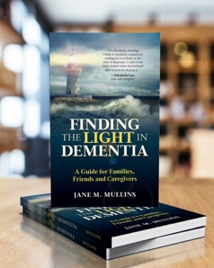

http://amzn.to/2ARCwDI

All rights reserved. This activity book is only to be downloaded and completed by each individual trainee. No part of this training may be copied for use other than intended for each trainee. This training programme is the culmination of over 30 years’ practice and experience in dementia care and teaching in Health and Social Care and contributions by people living with dementia and professionals working within the field. Please see terms and conditions at www.findingthelightindementiacaretraining.com for full details.

