Module Three
Using Memories to Keep in Touch
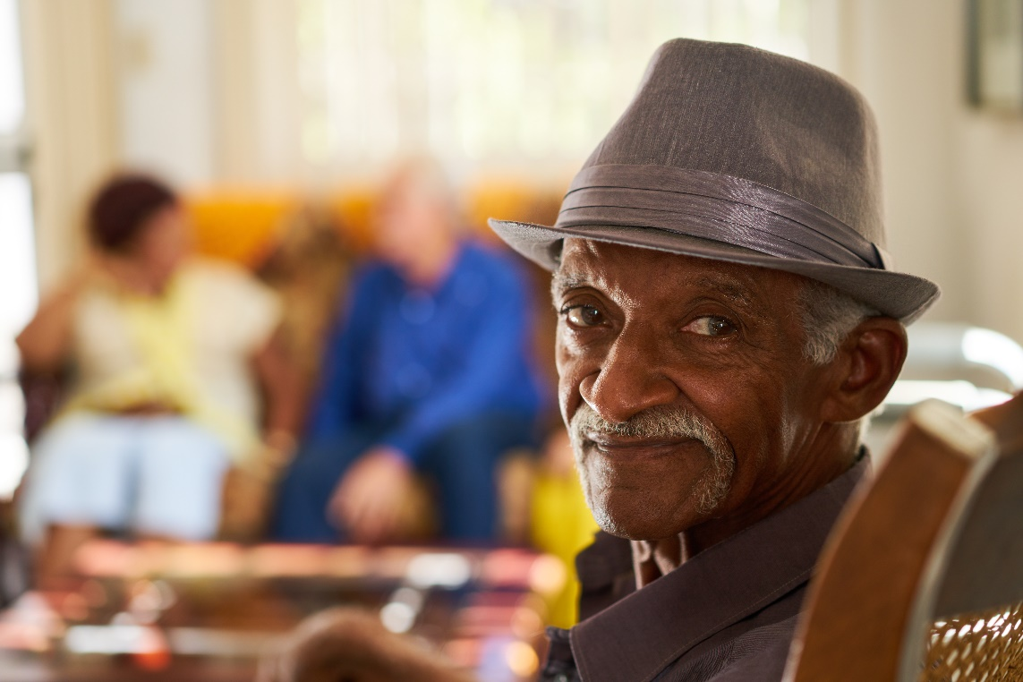

ACTIVITY BOOK

Name:
Date completed:

Manager’s signature on completion:

Well done for completing Module Two, excellent work!

This Module will be building on what we have learnt in the last two. Here we can care more with dignity, understand the needs of the people we care with and try and imagine how we might feel in response to their experiences of the world around them. This will help us to build trusting relationships with them.
As we go through the masterclasses, films, animations, and audios we will learn about the different types of memory we experience and how memory is affected by dementia. We will learn novel ways of stimulating memory including life story work and reminiscence and how our senses link to memory and our emotions. In doing this we will be building on our knowledge that will help us care with people living with dementia and help you care for yourself with the respect and dignity you both deserve.

By watching the resources, and completing the Activity Book, you will learn to connect with the people you care with and help support them with all of their physical and emotional needs, while developing your own inner confidence.
Also don’t forget to use your Reflective Journal to reflect on your thoughts, ideas and insights and how the training is helping you. Remember a big part of this training is for your own development and will involve some enjoyable activities.
Don’t forget to be kind to yourself by having some breaks, go to the Wellbeing Hub and if you can go and get some fresh air in and around nature you will feel great. Jane
Dr. Jane M. Mullins Dementia Nurse Specialist
Founder of Finding the Light in Dementia®

Module Three
Using Memories to Keep in Touch: Learning Outcomes
Sometimes you may never know the value of a moment
until it becomes a memory

Dr Seuss
In this module, we are going to understand what memory is and learn about the process of remembering and forgetting and how our senses can affect our memory. By building on our knowledge from Modules One and Two we will go on to see how dementia may affect memory, from the early stages, and as their condition progresses (depending on the type of dementia a person has). We will do this by watching films, animations and presentations, and listening to audio recordings. These resources involve people who have dementia, family members, carers and professionals and researchers working within the field.
Using strength-based approaches we will go on to examine ways of communicating with people through their life stories and biographies using creative ways and learn how to support people to help retain their existing skills for as long as possible, to help provide person centred care.
This training will give you more confidence and spark off your own ideas to help people living with dementia and their loved ones. Your manager will be there to support you and don’t forget to work closely with your buddy and other colleagues. A number of these activities may bring out a number of emotions, so don’t forget to speak with your manager (or trusted friend/colleague) about this and visit our Wellbeing Hub.

This Activity Book has a mixture of notes pages for you to write in when watching the presentations and other resources in each lesson and activities to complete.

Don’t forget the Wellbeing Hub will help you with many of your self-care needs during this training. However, it is not a substitute for medical advice and DUETcare Ltd cannot be held responsible for your health and wellbeing. If at any time you feel overwhelmed and needing support, please speak with your manager/buddy or trusted friend and seek medical help where required.

Activities

One: Making a Cuppa 5

Two: Recalling a Memory to a Friend 8

Three: Life Story 10

Four: Reminiscence 11

Five: A Travelbag of Memories 14

Six: 3 Things Learnt 15

Activity One: Making a Cuppa

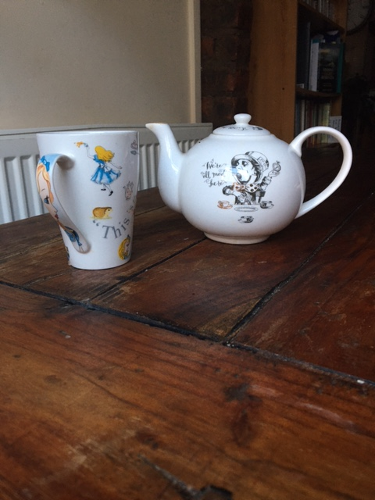

I am sure that all of us have a favourite drink that we often associate with chilling out and relaxing with. In this activity, I’d like you to think about making your favourite drink (I give the example of a cup of tea here).
When we make a cup of tea, we are using our Working memory - a system in the brain that provides temporary storage and manipulation of the information needed to complete such a task (which has many stages to it). This also includes language comprehension, learning, judgement and reasoning.
Describe below the different stages of making a cuppa and include judgements (e.g., assessing risks) we make during the task. Think about how many stages there are in making a cup of tea. We also initiate the idea in the first place of wanting a cup and maybe feeling thirsty – two things that dementia may affect over time.

Activity One: Working Memory and Making a Cuppa cont...

Stages in making a Cup of your favourite drink

Activity One: Making a Cuppa cont...
These are the stages I have considered, can you think of any others?
It shows how complicated (and the number of brain processes required) in what has become an automatic task for us to undertake. Write below each point what will happen if any of those stages is missed or misjudged.
- Go to the tap, remembering which is the cold one

- Fill the kettle, judging how high to fill it

- Carry kettle back to electrical source

- Remember to turn kettle on

- Take out cup(s) (and maybe teapot) out of the cupboard

- Measure in correct amount of tea/teabag

- Assess/judge when kettle has boiled

- Turn kettle off (if not automatic)

- Pour boiling water into cup(s)/teapot, judging that if not careful you could scald yourself (also relies on eyesight)

- Judge how much water to put in

- (If you take milk) – Go to the fridge and take out milk

- Shut fridge door (to keep food fresh)

- Judge how much milk to pour in (also relies on eyesight)

- (If you take sugar) – Go to the drawer for a spoon

- Judge how much sugar you need to go in the cup

- Stir it

- Then drink (careful not to scald/yourself)

Activity Two: Recalling a Memory to a Friend

Partner up with your buddy or colleague or manager and take it in turns to be the Story teller and the Listener.

As the Storyteller tell the Listener about your first memory, or a favourite memory (think about the people, places and experiences involved in this memory and the senses involved e.g., smells in a sweet shop, watching bubbles floating in the air, sounds). Remember all that you learnt in Module Two about communicating and listening.

Swap places after 5 minutes then write down your responses to these questions:

How did it feel to tell someone about this memory?

Were you surprised by how much you could remember?

How did it feel to be listened to?

What senses did you think about in relation to your memory?

Activity Two: Recalling a Memory to a Friend cont…

How do you think you might feel if you struggled to recall this memory?

What approaches could you use to help the people you care with try to recall some of their memories (think about the senses here)?

Activity Three: Life Story

Choose a person that you care with and with their and their family’s permission (depending on whether the person is able to make the decision) and involvement start to conduct life story work, (based on the presentation) you may do this in the form of a vision board, a memory box or a lifeline or all three! This is likely to be an ongoing activity over time.

Write below your thoughts when undertaking this activity:

Write below how you felt when undertaking this activity:

Activity Four: Reminiscence
This is a group activity to undertake with your colleagues and manager. Read through the following excerpt (giving everyone enough time to read it) and then nominate one member of staff to read out loud (only if they are comfortable doing this). Discuss together, then write your comments in the boxes below.

After a morning in the care home, two care workers decided to start an activity. They brought in a box of reminiscence objects into the lounge and quickly helped a few people to move their chairs to make a group of 9 people. Despite the moves the chairs were not well placed and some people could not hear or see each other very well. The activity was run like a quiz game. Residents who named an object correctly were praised. Those who didn’t were asked to pass it on.

Eileen held a pack of penny blue for quite a while, looking at it intently. She was asked to pass it on to the next person, and when she eventually spoke, no-one was listening. Lakshmi was given the thimble and said quietly “silver thimble. Mother had one. She made all our lovely dresses we had lovely clothes.” A member of staff said “that’s a lovely memory Lakshmi”, and repeated what she had said so everyone could hear. Several other people chipped in with memories triggered by Lakshmi’s story. Sally began to cry when she was holding the darning mushroom. A member of the care staff asked, “Are you crying about your brother? And she nodded, continuing to cry. She was given no further attention. When he smelt the carbolic soap, Scott began to tell an animated story about his grandmother’s chickens. When he paused one of the care staff said, “Scott remembers a lot about his grandma’s chickens but we’re not talking about animals today, we’re talking about household things”. Amir could not hear what was going on, and pointed out that it was raining outside. The activity ended abruptly without explanation when the staff were called away to help someone in the toilet.

Activity Four: Reminiscence cont…

What went well in the above example?

Activity Four: Reminiscence cont…
What areas of practice could be improved to make sure that everyone was included and listened to?

Activity Five: A Travelbag of Memories

Create a sensory holiday reminiscence day with the people you care with, find out what their favourite holidays are/were and help them explore objects, sounds, smells and films. (Be mindful of not over stimulating them, you will need to observe how people respond). Help them reconnect to memories of joy and where possible involve their families and friends. Write below what things you explored (remember to maintain confidentiality here, you can always give the person a “pen name.” You can continue your descriptions on the next page (include drawings if you’d like to).

If this is not possible e.g., you may work on an acute hospital ward, do this activity with a friend or relative.

e.g., Where was the holiday,
Travel arrangements (did it enjoy flight, a bus, train)?
What sensory tools could you use to stimulate an emotion?
- Photos
- Sounds
- Food
- Drink
- Objects

Write/draw below what you observed, how did the person respond?

Activity Six: Three Things Learnt
Write down 3 things you have learnt since you started Module Three.

Well done!!

For completing Module Three, “Using Memories to Keep in Touch”.

You should now be able to understand about our different types of memory and how dementia can affect this. You will also be able to find creative, enjoyable ways of helping connect with the people you care with by using sensory reminiscence techniques, whilst also being mindful of the potential of triggering negative memories and emotions.

If you are printing this up, I hope you have managed to get a file, as you can add the others from the next modules to it or you could create an electronic file for all of your Activity Books, Reflective Journals, Presentation Notes Pages and Certificates. By keeping it all together, you will see how your knowledge and skills will have developed and it will be a great resource to refer back to when you have completed the training.

Also don’t forget to use your Reflective Journal alongside to write down any extra notes, thoughts and observations. You can also learn more from my book, Finding the Light in Dementia: A Guide for Families, Friends and Caregivers.

Don’t forget to answer the questions at the end of the Module to release your certificate and store safely in your file and visit the Wellbeing Hub.

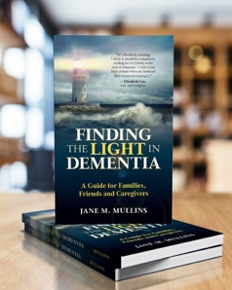

http://amzn.to/2ARCwDI

All rights reserved. This activity book is only to be downloaded and completed by each individual trainee. No part of this training may be copied for use other than intended for each trainee. This training programme is the culmination of over 30 years’ practice and experience in dementia care and teaching in Health and Social Care and contributions by people living with dementia and professionals working within the field. Please see terms and conditions at www.findingthelightindementiacaretraining.com for full details.

